

Lab Journal: 06
Date: 10/16/2025

Student : Lotfullah Muslimwal
Enrollment : 01-131232-039

Department of Software Engineering

Bahria University, Islamabad

Visual Programming-Lab (Fall-2025)
Teacher: Engr. RAHEELA AMBRIN

Task No: | Task Wise Marks |  | Documentation Marks |  | Total Marks  (20)
 | Assigned | Obtained | Assigned | Obtained
1 | 3 |  | 5
2 | 3
3 | 3
4 | 3
5 | 3

Comments:

Signature

Lab No: 06 - Lab Title: GUI Controls and Layout Management

Tools Used
- Visual Studio
Task 6.1:
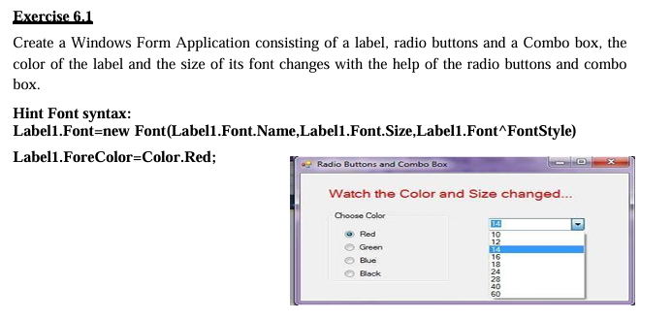
Code: Task 1 Code
Screenshot
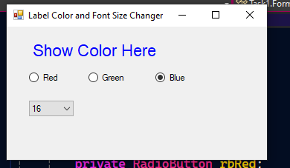

Task 6.2:
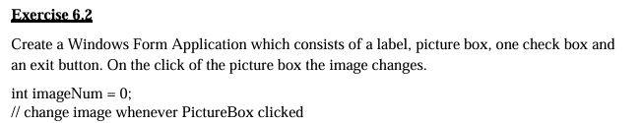

Code: Code For Task 2

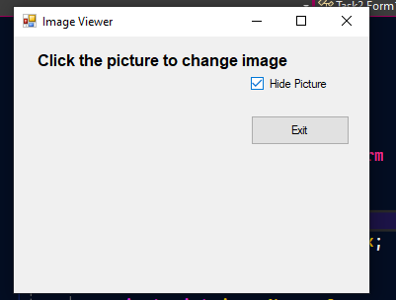
Screenshot
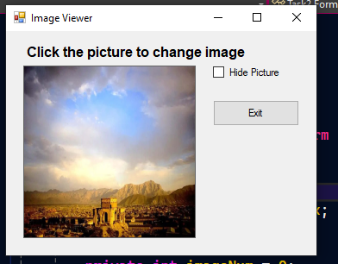

Task 6.3: 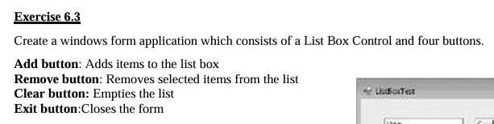

Code: Code for Task 3

Screenshot
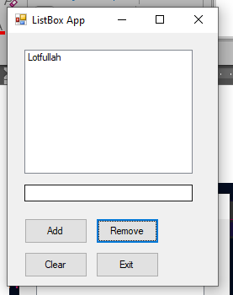
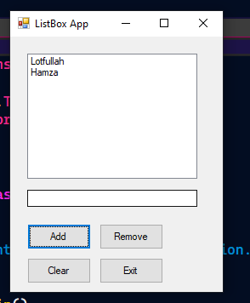

Task 6.4:
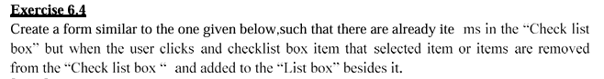
Code: Code for Task 4

Screenshot
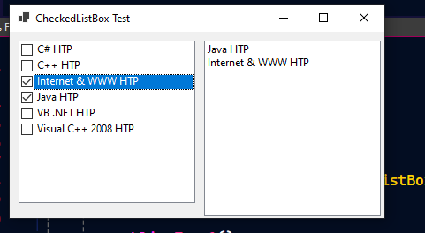

Task 3.5:
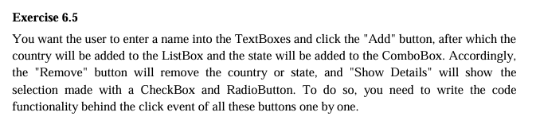
Code: Code for Task 5
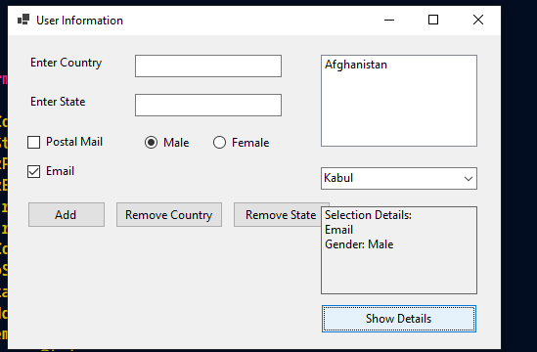

GitHub repository: Code For Lab 6

